|  |  |  |  |
| --- | --- | --- | --- |
| Revision History | | | |
| Name | Date | Reason for Changes | Version |
| Ridhima Joshi | 09/25/2018  09/26/2018 | Initial Use Cases  Change in Admin Use Case | Admin 1.0  Admin 1.1 |
| Pratyusha | 09/25/2018 |  | User 1.0 |
| Saiphanideep | 09/25/2018 |  | Guest 1.0  Timer 1.0 |
|  |  |  |  |

Use Case Scenario #1

**1.0 Use Case for UHCL User**

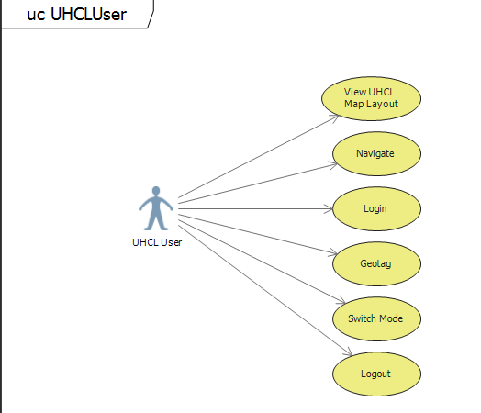

|  |  |  |  |  |
| --- | --- | --- | --- | --- |
| UHCL User Use Case | | | | |
| **Use Case Name** | UHCL User | **Use Case ID** | 1.0 |
| **Created By** | UI Interior | **Date Created** | 09/25/2018 |
| **Updated By** | Pratyusha | **Date Last Updated** |  |
| **Approved By** |  | **Date Approved** |  |
| **Primary Actor** | UHCL User | **Secondary Actors** |  |
| **Brief Description** | Various tasks performed by the UHCL User while using the application. | | |
| **Trigger** |  | | |
| **Preconditions** | The UHCL User must be connected to the UHCL public or private wifi connection. | | |
| **Postconditions** | UHCL User must be able to perform all the tasks specified using the application. | | |
| **Normal Flows** | 1. User logs into the application using the username and password. 2. User can select one of the options 3. View UHCL Map Layout. 4. Navigate to the specified destination. 5. Geotag a particular location. 6. Switch modes. 7. User logs out of the application. | | |
| **Alternative Flows** |  | | |
| **Exceptions** |  | | |
| **Priority** | High | | |
| **Frequency of Use** |  | | |
| **Business Rules** |  | | |
| **Other Information** | UHCL User can perform 2.(d) only in 2.(b) task. | | |
| **Assumptions** | UHCL User is connected to the UHCL wifi connection. | | |

**1.1 Use case for UHCL User Login**

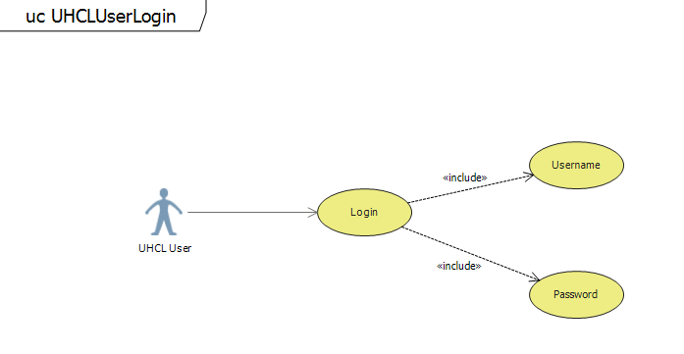

|  |  |  |  |  |
| --- | --- | --- | --- | --- |
| UHCL User Login Use Case | | | | |
| **Use Case Name** | UHCL User | **Use Case ID** | 1.1 |
| **Created By** | UI Interior | **Date Created** | 09/25/2018 |
| **Updated By** | Pratyusha | **Date Last Updated** |  |
| **Approved By** |  | **Date Approved** |  |
| **Primary Actor** | UHCL User | **Secondary Actors** |  |
| **Brief Description** |  | | |
| **Trigger** |  | | |
| **Preconditions** |  | | |
| **Postconditions** |  | | |
| **Normal Flows** |  | | |
| **Alternative Flows** |  | | |
| **Exceptions** |  | | |
| **Priority** |  | | |
| **Frequency of Use** |  | | |
| **Business Rules** |  | | |
| **Other Information** |  | | |
| **Assumptions** |  | | |

**1.2 Use case for View UHCL Map Layout**

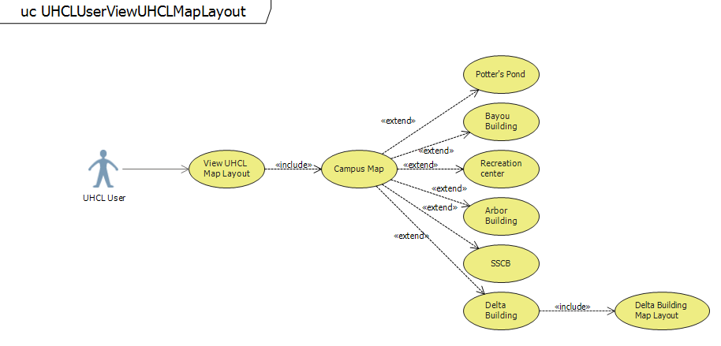

|  |  |  |  |  |
| --- | --- | --- | --- | --- |
| UHCL User View UHCL Map Layout Use Case | | | | |
| **Use Case Name** | UHCL User | **Use Case ID** | 1.2 |
| **Created By** | UI Interior | **Date Created** | 09/25/2018 |
| **Updated By** | Pratyusha | **Date Last Updated** |  |
| **Approved By** |  | **Date Approved** |  |
| **Primary Actor** | UHCL User | **Secondary Actors** |  |
| **Brief Description** |  | | |
| **Trigger** |  | | |
| **Preconditions** |  | | |
| **Postconditions** |  | | |
| **Normal Flows** |  | | |
| **Alternative Flows** |  | | |
| **Exceptions** |  | | |
| **Priority** |  | | |
| **Frequency of Use** |  | | |
| **Business Rules** |  | | |
| **Other Information** |  | | |
| **Assumptions** |  | | |

**1.3 Use case for User Navigation**

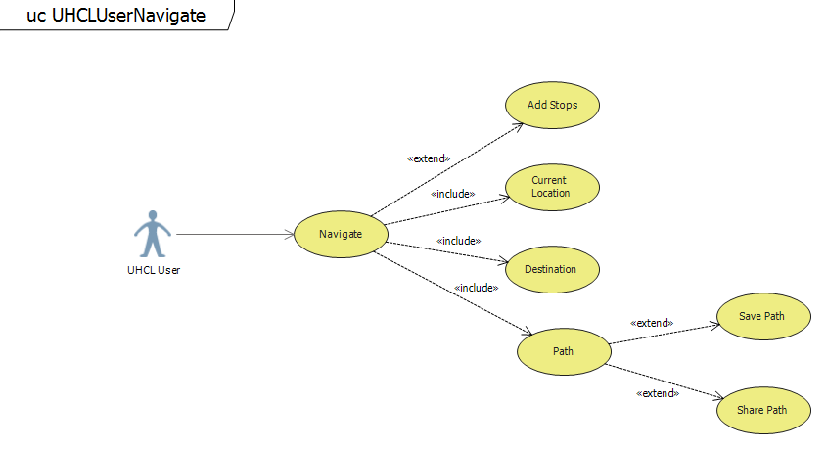

|  |  |  |  |  |
| --- | --- | --- | --- | --- |
| UHCL User Navigate Use Case | | | | |
| **Use Case Name** | UHCL User | **Use Case ID** | 1.3 |
| **Created By** | UI Interior | **Date Created** | 09/25/2018 |
| **Updated By** | Pratyusha | **Date Last Updated** |  |
| **Approved By** |  | **Date Approved** |  |
| **Primary Actor** | UHCL User | **Secondary Actors** |  |
| **Brief Description** |  | | |
| **Trigger** |  | | |
| **Preconditions** |  | | |
| **Postconditions** |  | | |
| **Normal Flows** |  | | |
| **Alternative Flows** |  | | |
| **Exceptions** |  | | |
| **Priority** |  | | |
| **Frequency of Use** |  | | |
| **Business Rules** |  | | |
| **Other Information** |  | | |
| **Assumptions** |  | | |

**1.5 Use case for Switching Modes**

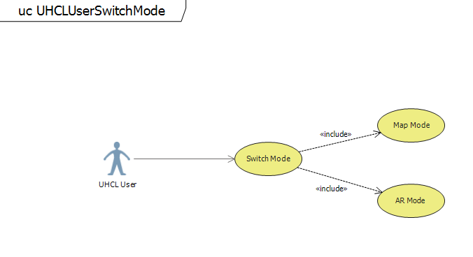

|  |  |  |  |  |
| --- | --- | --- | --- | --- |
| UHCL User Use Case | | | | |
| **Use Case Name** | UHCL User | **Use Case ID** | 1 |
| **Created By** | UI Interior | **Date Created** | 09/25/2018 |
| **Updated By** | Pratyusha | **Date Last Updated** |  |
| **Approved By** |  | **Date Approved** |  |
| **Primary Actor** | UHCL User | **Secondary Actors** |  |
| **Brief Description** |  | | |
| **Trigger** |  | | |
| **Preconditions** |  | | |
| **Postconditions** |  | | |
| **Normal Flows** |  | | |
| **Alternative Flows** |  | | |
| **Exceptions** |  | | |
| **Priority** |  | | |
| **Frequency of Use** |  | | |
| **Business Rules** |  | | |
| **Other Information** |  | | |
| **Assumptions** |  | | |

**1.6 Use case for Geotagging**

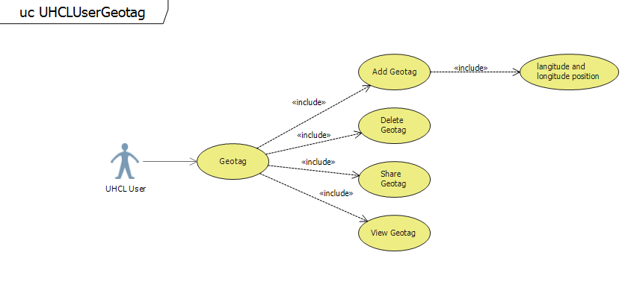

|  |  |  |  |  |
| --- | --- | --- | --- | --- |
| UHCL User Use Case | | | | |
| **Use Case Name** | UHCL User | **Use Case ID** | 1 |
| **Created By** | UI Interior | **Date Created** | 09/25/2018 |
| **Updated By** | Pratyusha | **Date Last Updated** |  |
| **Approved By** |  | **Date Approved** |  |
| **Primary Actor** | UHCL User | **Secondary Actors** |  |
| **Brief Description** |  | | |
| **Trigger** |  | | |
| **Preconditions** |  | | |
| **Postconditions** |  | | |
| **Normal Flows** |  | | |
| **Alternative Flows** |  | | |
| **Exceptions** |  | | |
| **Priority** |  | | |
| **Frequency of Use** |  | | |
| **Business Rules** |  | | |
| **Other Information** |  | | |
| **Assumptions** |  | | |

**1.7 Use case for Logging out**

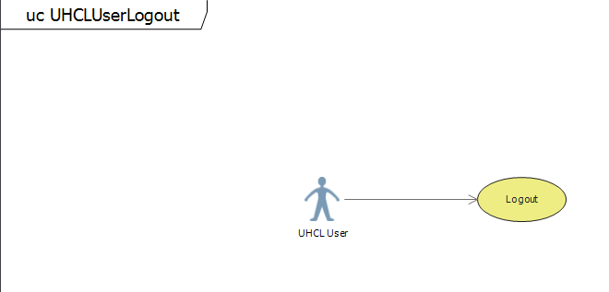

|  |  |  |  |  |
| --- | --- | --- | --- | --- |
| UHCL User Use Case | | | | |
| **Use Case Name** | UHCL User | **Use Case ID** | 1 |
| **Created By** | UI Interior | **Date Created** | 09/25/2018 |
| **Updated By** | Pratyusha | **Date Last Updated** |  |
| **Approved By** |  | **Date Approved** |  |
| **Primary Actor** | UHCL User | **Secondary Actors** |  |
| **Brief Description** |  | | |
| **Trigger** |  | | |
| **Preconditions** |  | | |
| **Postconditions** |  | | |
| **Normal Flows** |  | | |
| **Alternative Flows** |  | | |
| **Exceptions** |  | | |
| **Priority** |  | | |
| **Frequency of Use** |  | | |
| **Business Rules** |  | | |
| **Other Information** |  | | |
| **Assumptions** |  | | |

|  |  |  |  |  |
| --- | --- | --- | --- | --- |
| UHCL User Use Case | | | | |
| **Use Case Name** | UHCL User | **Use Case ID** | 2 |
| **Created By** | Pratyusha | **Date Created** | 09/25/18 |
| **Updated By** |  | **Date Last Updated** |  |
| **Approved By** |  | **Date Approved** |  |
| **Primary Actor** | UHCL User | **Secondary Actors** |  |
| **Brief Description** | Defining the various user functionalities of the user while using the UHCL Navigator Application. | | |
| **Trigger** | The user current location must be know. | | |
| **Preconditions** | 1.The user needs to be connected to mobile data or wifi connection.  2. User needs to Register in order to Login the Application. | | |
| **Postconditions** | 1. User Login Successfully.  2. User will reach the desired location.  2. User can Geotag locations.  3. User can Share locations.  4. User can view Saved locations. | | |
| **Normal Flows** | 1. User needs to Register to Login.  2. Login to the Application.  3. User can view the locations available to navigate around the UHCL campus.  4. User can Enter or select a destination.  5. User navigates around the campus.  5.1.1 User can save the current location.  5.1.2 User can use Voice Navigation.  5.1.3 User can save the current path.  5.1.4 User can view the Distance to destination.  5.1.5 User can Share the saved path.  5.2 User can switch modes while navigating.  5.2.1 User can switch to Map Mode.  5.2.2 User can switch to AR Mode.  6. Once the destination is reached the User needs to be notified by the system.  7. User can Geotag various locations on the campus.  7.1 User can save the Geotagged places.  7.2 User can share the Geotagged places.  7.3 User can view the Geotagged places.  7.4 User can Delete the Geotagged places. | | |
| **Alternative Flows** | 2. Login Unsuccessful.   1. User needs to enter the valid Username 2. User needs to enter a valid Password. 3. The User can successfully Login.   4. User enters an invalid destination.   1. Prompt a message asking the user to enter a valid destination.   5.1.2 Voice Navigation not recognised.   1. User should enter the instructions manually. | | |
| **Exceptions** |  | | |
| **Priority** |  | | |
| **Frequency of Use** |  | | |
| **Business Rules** |  | | |
| **Other Information** |  | | |
| **Assumptions** | The user is connected to a network. | | |

Use Case Scenario #2

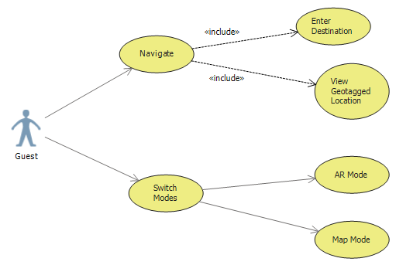

|  |  |  |  |  |
| --- | --- | --- | --- | --- |
| Guest Case Template | | | | |
| **Use Case Name** | Guest | **Use Case ID** | 1 |
| **Created By** | UI Interior | **Date Created** | 09/25/2018 |
| **Updated By** | Saiphanideep | **Date Last Updated** |  |
| **Approved By** |  | **Date Approved** |  |
| **Primary Actor** | Guest | **Secondary Actors** |  |
| **Brief Description** | Guest user tries to Navigate and also he can change modes. | | |
| **Trigger** | Must know the current user position. | | |
| **Preconditions** | 1.The Guest needs to be connected to mobile data or else the router connection. | | |
| **Postconditions** | 2. The Guest should be navigated to which ever Destination he selects. | | |
| **Normal Flows** | 1.User will start Navigation.  2.User will enter the destination.  3.User can view geotagged locations.  4.User can switch to AR mode.  5.User can switch to Map mode. | | |
| **Alternative Flows** | 1.User can switch to either AR mode.  2.User can switch to Map mode. | | |
| **Exceptions** |  | | |
| **Priority** |  | | |
| **Frequency of Use** |  | | |
| **Business Rules** |  | | |
| **Other Information** |  | | |
| **Assumptions** | The Guest is connected to a network. | | |

Use Case Scenario #3 Admin

**3.0 Use Case for Admin Functionalities**

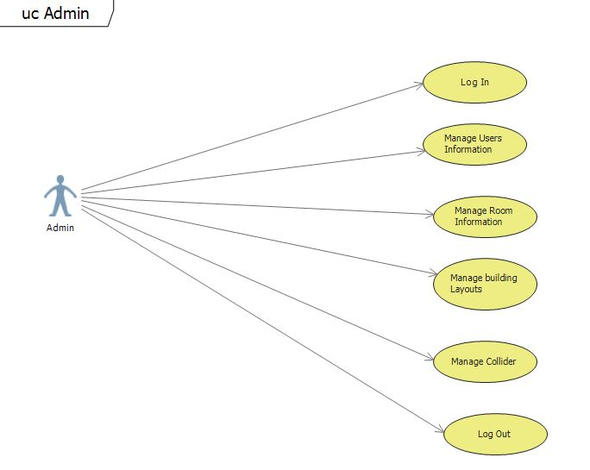

Figure 3.0: Use Case Diagram for Admin Functionalities

|  |  |  |  |  |
| --- | --- | --- | --- | --- |
| Admin Use Case | | | | |
| **Use Case Name** | Admin | **Use Case ID** | 3.0 |
| **Created By** | Ridhima Joshi | **Date Created** | 09/25/2018 |
| **Updated By** | Ridhima Joshi | **Date Last Updated** | 09/26/2018 |
| **Approved By** |  | **Date Approved** |  |
| **Primary Actor** | Admin | **Secondary Actors** |  |
| **Brief Description** | Admin performs various tasks using the application. | | |
| **Trigger** |  | | |
| **Preconditions** | Admin must be connected to the internet. | | |
| **Postconditions** | Admin must be able to perform the tasks using the applications. | | |
| **Normal Flows** | 1. Admin logs into the application using his/her valid credentials. 2. Admin views the options of    1. Managing the User Information.    2. Managing the Room Information    3. Managing the Building Layouts.    4. Managing the Colliders 3. Admin logs out of the application. | | |
| **Alternative Flows** | None. | | |
| **Exceptions** |  | | |
| **Priority** | High | | |
| **Frequency of Use** |  | | |
| **Business Rules** |  | | |
| **Other Information** |  | | |
| **Assumptions** | Admin is connected to the internet. | | |

**3.1 Use Case for Admin Login Functionality**

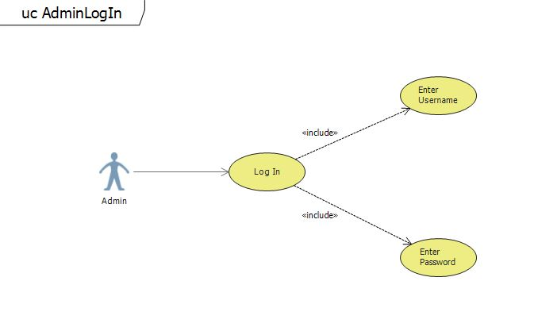

Figure 3.1: Use Case Diagram for Admin Login Functionality

|  |  |  |  |  |
| --- | --- | --- | --- | --- |
| Admin Login Use Case | | | | |
| **Use Case Name** | Admin Login | **Use Case ID** | 3.1 |
| **Created By** | Ridhima Joshi | **Date Created** | 09/25/2018 |
| **Updated By** |  | **Date Last Updated** |  |
| **Approved By** |  | **Date Approved** |  |
| **Primary Actor** | Admin | **Secondary Actors** |  |
| **Brief Description** | Admin provides his/her username and password to access the application. | | |
| **Trigger** | Admin opens the application. | | |
| **Preconditions** | 1. Admin must be connected to the internet. 2. Admin must have valid credentials. | | |
| **Postconditions** | Admin shall be able to logged in the application. | | |
| **Normal Flows** | 1.0 Admin provides valid credentials.   1. Admin shall provide valid credentials. 2. Admin clicks the login button. 3. Admin is logged into the application. | | |
| **Alternative Flows** | None. | | |
| **Exceptions** | 1.1 Admin provides invalid credentials.  1.1.1 The username is invalid:  a) The admin is prompted to re enter the username.  1.1.2.The password is invalid:  a) The admin is prompted to re enter the password. | | |
| **Priority** | High | | |
| **Frequency of Use** | Whenever the application is accessed. | | |
| **Business Rules** |  | | |
| **Other Information** |  | | |
| **Assumptions** | Admin must have an internet connection. | | |

**3.2 Use Case for Admin Managing User Information Functionality**

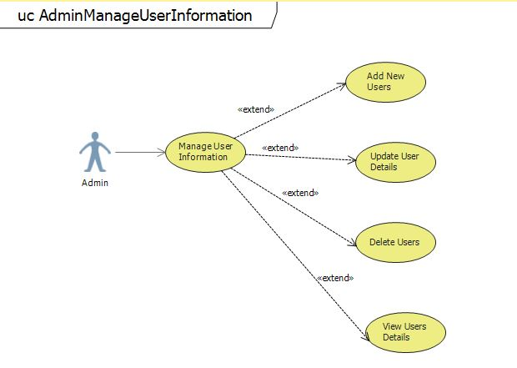

Figure 3.2: Use Case Diagram for Admin Managing User Information Functionality

|  |  |  |  |  |
| --- | --- | --- | --- | --- |
| Managing User Information Use Case | | | | |
| **Use Case Name** | Manage Users Information | **Use Case ID** | 3.2 |
| **Created By** | Ridhima Joshi | **Date Created** | 09/25/2018 |
| **Updated By** |  | **Date Last Updated** |  |
| **Approved By** |  | **Date Approved** |  |
| **Primary Actor** | Admin | **Secondary Actors** |  |
| **Brief Description** | Admin can manage the information of users who has the access to the admin application. | | |
| **Trigger** | The admin will select Manage User’s Information option from the menu. | | |
| **Preconditions** | Admin should be logged in. | | |
| **Postconditions** | Admin should view the next menu screen for managing users. | | |
| **Normal Flows** | 1. Admin logs in with valid credentials. 2. Admin selects Manage User Information option from the menu. | | |
| **Alternative Flows** | None | | |
| **Exceptions** | 1.1 Admin provides invalid credentials.  1.1.1 The username is invalid:  a) The admin is prompted to re enter the username.  1.1.2 The password is invalid:  a) The admin is prompted to re enter the password.  1.1.3 Upon entry of a valid username and password the admin gains entry to the system. | | |
| **Priority** |  | | |
| **Frequency of Use** |  | | |
| **Business Rules** |  | | |
| **Other Information** |  | | |
| **Assumptions** | The admin is connected to the internet. | | |

**3.2.1 Use Case for Adding New User Information Functionality**

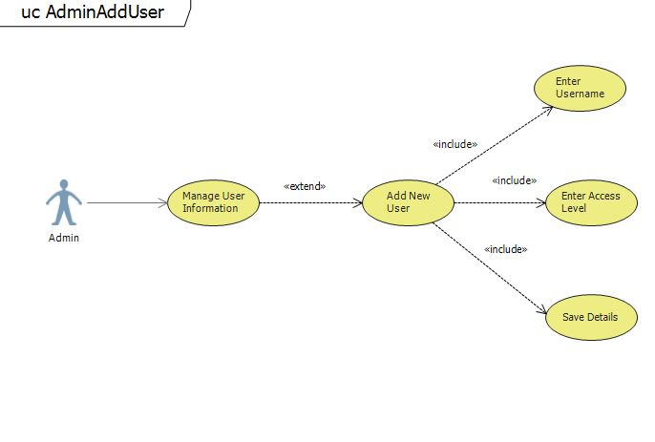

Figure 3.2.1: Use Case Diagram for Adding New User Information Functionality

|  |  |  |  |  |
| --- | --- | --- | --- | --- |
| Add New User Use Case | | | | |
| **Use Case Name** | Add New User Information | **Use Case ID** | 3.2.1 |
| **Created By** | Ridhima Joshi | **Date Created** | 09/25/2018 |
| **Updated By** |  | **Date Last Updated** |  |
| **Approved By** |  | **Date Approved** |  |
| **Primary Actor** | Admin | **Secondary Actors** |  |
| **Brief Description** | Admin will be able to add new admin users and allocate access. | | |
| **Trigger** | Admin selects Add New User option. | | |
| **Preconditions** | Admin should be logged in. | | |
| **Postconditions** | New users should be saved in the database. | | |
| **Normal Flows** | 1. Admin logs in the application with valid credentials. 2. Admin selects Manage User Information option from the menu. 3. Admin selects Add New User option. 4. Admin enters the username of the new user. 5. Admin enters the access level to the new user. 6. Admin clicks on Save button. | | |
| **Alternative Flows** | None | | |
| **Exceptions** | 1.1 Admin provides invalid credentials.  1.1.1 The username is invalid:  a) The admin is prompted to re enter the username.  1.1.2.The password is invalid:  a) The admin is prompted to re enter the password.  1.1.3. Upon entry of a valid username and password the admin gains entry to the system  6.1 Admin clicks on Save button  a)The admin is prompted unable to save the data.  b) The admin is prompted that user already exists. | | |
| **Priority** |  | | |
| **Frequency of Use** |  | | |
| **Business Rules** |  | | |
| **Other Information** |  | | |
| **Assumptions** | The admin is connected to the internet. | | |

**3.2.2 Use Case for Updating User Details Functionality**

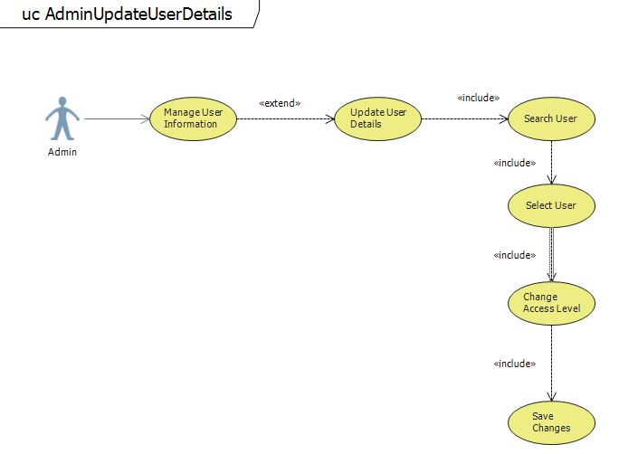

Figure 3.2.2: Use Case Diagram for Update User Details Functionality

|  |  |  |  |  |
| --- | --- | --- | --- | --- |
| Update User Details Use Case | | | | |
| **Use Case Name** | Update User Details | **Use Case ID** | 3.2.2 |
| **Created By** | Ridhima Joshi | **Date Created** | 09/25/2018 |
| **Updated By** |  | **Date Last Updated** |  |
| **Approved By** |  | **Date Approved** |  |
| **Primary Actor** | Admin | **Secondary Actors** |  |
| **Brief Description** | Admin can update user details. | | |
| **Trigger** | Admin selects the option of Updating User Details. | | |
| **Preconditions** | Admin must be logged in. | | |
| **Postconditions** | Admin should be able to modify the details of the user. | | |
| **Normal Flows** | 1. Admin logs in the application with valid credentials. 2. Admin selects Manage User Information option from the menu. 3. Admin selects Update User Details option. 4. Admin searches the user whose details are to be updated. 5. Admin selects the user. 6. Admin updates the access level for the user. 7. Admins clicks on Update button. | | |
| **Alternative Flows** | None | | |
| **Exceptions** | 1.1 Admin provides invalid credentials.  1.1.1 The username is invalid:  a) The admin is prompted to re enter the username.  1.1.2.The password is invalid:  a) The admin is prompted to re enter the password.  1.1.3. Upon entry of a valid username and password the admin gains entry to the system  7.1 Admin clicks on save button  a)The admin is prompted unable to update the data. | | |
| **Priority** |  | | |
| **Frequency of Use** |  | | |
| **Business Rules** |  | | |
| **Other Information** |  | | |
| **Assumptions** | The admin is connected to the internet. | | |

**3.2.3 Use Case for Deleting The User Functionality**

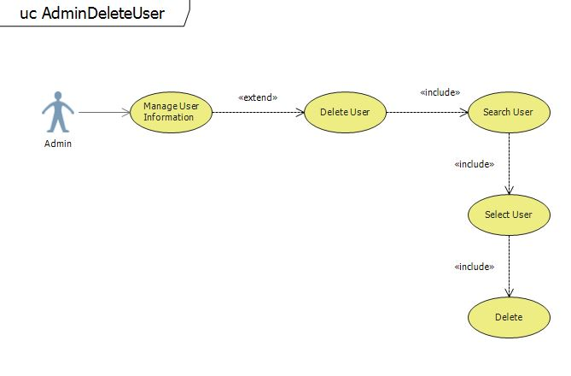

Figure 3.2.3: Use Case Diagram for Delete User Functionality

|  |  |  |  |  |
| --- | --- | --- | --- | --- |
| Delete User Use Case | | | | |
| **Use Case Name** | Delete User | **Use Case ID** | 3.2.3 |
| **Created By** | Ridhima Joshi | **Date Created** | 09/25/2018 |
| **Updated By** |  | **Date Last Updated** |  |
| **Approved By** |  | **Date Approved** |  |
| **Primary Actor** | Admin | **Secondary Actors** |  |
| **Brief Description** | Admin deletes a selected user. | | |
| **Trigger** | Admin selects the Delete User option. | | |
| **Preconditions** | Admin should be logged in. | | |
| **Postconditions** | The user should be deleted from the database. | | |
| **Normal Flows** | 1. Admin logs in the application with valid credentials. 2. Admin selects manage user information option from the menu. 3. Admin selects Delete User option. 4. Admin searches the user to be deleted. 5. Admin selects the user which he wants to remove from the system. 6. Admin clicks on the Delete button. | | |
| **Alternative Flows** | None | | |
| **Exceptions** | 1.1 Admin provides invalid credentials.  1.1.1 The username is invalid:  a) The admin is prompted to re enter the username.  1.1.2.The password is invalid:  a) The admin is prompted to re enter the password.  1.1.3. Upon entry of a valid username and password the admin gains entry to the system  5.1 Admin searches the user   1. The admin is prompted user not found.   6.1 Admin clicks on delete button  a)The admin is prompted unable to delete the data. | | |
| **Priority** |  | | |
| **Frequency of Use** |  | | |
| **Business Rules** |  | | |
| **Other Information** |  | | |
| **Assumptions** | The admin is connected to the internet. | | |

**3.2.4 Use Case for Viewing User Details Functionality**

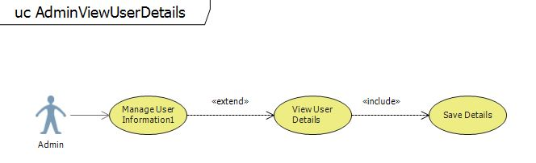

Figure 3.2.4: Use Case Diagram for Delete User Functionality

|  |  |  |  |  |
| --- | --- | --- | --- | --- |
| View User Details Use Case | | | | |
| **Use Case Name** | View User Details | **Use Case ID** | 3.2.4 |
| **Created By** | Ridhima Joshi | **Date Created** | 09/25/2018 |
| **Updated By** |  | **Date Last Updated** |  |
| **Approved By** |  | **Date Approved** |  |
| **Primary Actor** | Admin | **Secondary Actors** |  |
| **Brief Description** | Admin can view all the user details. | | |
| **Trigger** | Admin selects View User Details option. | | |
| **Preconditions** | Admin should be logged in. | | |
| **Postconditions** | Admin should be able to view all user details. | | |
| **Normal Flows** | 1. Admin logs in the application with valid credentials. 2. Admin selects manage user information option from the menu. 3. Admin selects View User Details option. 4. Admin views all the details. 5. Admin clicks on Save button to save all the details. | | |
| **Alternative Flows** | None | | |
| **Exceptions** | 1.1 Admin provides invalid credentials.  1.1.1 The username is invalid:  a) The admin is prompted to re enter the username.  1.1.2.The password is invalid:  a) The admin is prompted to re enter the password.  1.1.3. Upon entry of a valid username and password the admin gains entry to the system  5.1 Admin clicks on save button  a)The admin is prompted unable to download the data. | | |
| **Priority** |  | | |
| **Frequency of Use** |  | | |
| **Business Rules** |  | | |
| **Other Information** |  | | |
| **Assumptions** | The admin should be connected to the internet. | | |

**3.3 Use Case for Admin Managing Room Information Functionality**

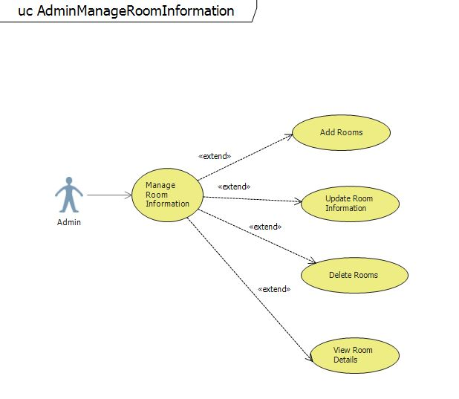

Figure 3.3: Use Case Diagram for Admin Managing Room Information Functionality

|  |  |  |  |  |
| --- | --- | --- | --- | --- |
| Managing Room Information Use Case | | | | |
| **Use Case Name** | Manage Room Information | **Use Case ID** | 3.3 |
| **Created By** | Ridhima Joshi | **Date Created** | 09/25/2018 |
| **Updated By** |  | **Date Last Updated** |  |
| **Approved By** |  | **Date Approved** |  |
| **Primary Actor** | Admin | **Secondary Actors** |  |
| **Brief Description** | The admin will select Manage Room Information option from the menu. | | |
| **Trigger** | Admin should be logged in. | | |
| **Preconditions** | Admin should view the next menu screen for Managing Room Information. | | |
| **Postconditions** | 1. Admin logs in with valid credentials. 2. Admin views Manage Room Information option from the menu. | | |
| **Normal Flows** | 1.1 Admin provides invalid credentials.  1.1.1 The username is invalid:  a) The admin is prompted to re enter the username.  1.1.2 The password is invalid:  a) The admin is prompted to re enter the password.  1.1.3 Upon entry of a valid username and password the admin gains entry to the system. | | |
| **Alternative Flows** | None. | | |
| **Exceptions** |  | | |
| **Priority** |  | | |
| **Frequency of Use** |  | | |
| **Business Rules** |  | | |
| **Other Information** |  | | |
| **Assumptions** |  | | |

**3.3.1 Use Case for Adding New Room Details Functionality**

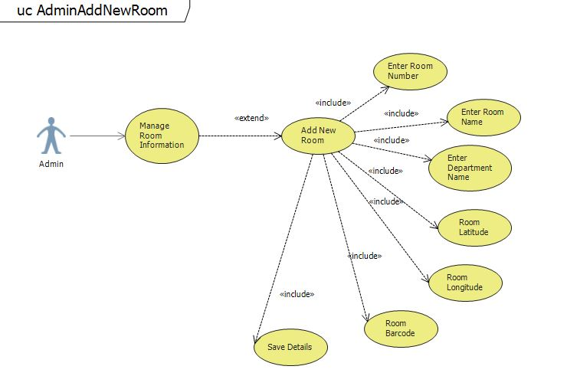

Figure: Use Case Diagram for Adding New Room Details Functionality

|  |  |  |  |  |
| --- | --- | --- | --- | --- |
| Adding New Room Details Use Case | | | | |
| **Use Case Name** | Add New Room Information | **Use Case ID** | 3.3.1 |
| **Created By** | Ridhima Joshi | **Date Created** | 09/25/2018 |
| **Updated By** |  | **Date Last Updated** |  |
| **Approved By** |  | **Date Approved** |  |
| **Primary Actor** | Admin | **Secondary Actors** |  |
| **Brief Description** | Admin will be able to add new rooms. | | |
| **Trigger** | Admin selects add new room option. | | |
| **Preconditions** | Admin should be logged in. | | |
| **Postconditions** | New rooms data should be saved in the database. | | |
| **Normal Flows** | 1. Admin logs in the application with valid credentials. 2. Admin selects Manage Room Information option from the menu. 3. Admin selects Add New Room option. 4. Admin enters the Room Number. 5. Admin enters the Room Name. 6. Admin enters the Department Name. 7. Admin enters the Room Latitude. 8. Admin enters the Room Longitude. 9. Admin enters the Room’s Barcode Information. 10. Admin clicks on Save button. | | |
| **Alternative Flows** | 1.1 Admin provides invalid credentials.  1.1.1 The username is invalid:  a) The admin is prompted to re enter the username.  1.1.2.The password is invalid:  a) The admin is prompted to re enter the password.  1.1.3. Upon entry of a valid username and password the admin gains entry to the system  9.1 Admin clicks on save button  a)The admin is prompted unable to save the data. | | |
| **Exceptions** |  | | |
| **Priority** |  | | |
| **Frequency of Use** |  | | |
| **Business Rules** |  | | |
| **Other Information** |  | | |
| **Assumptions** |  | | |

**3.3.2 Use Case for Update Room Details Functionality**

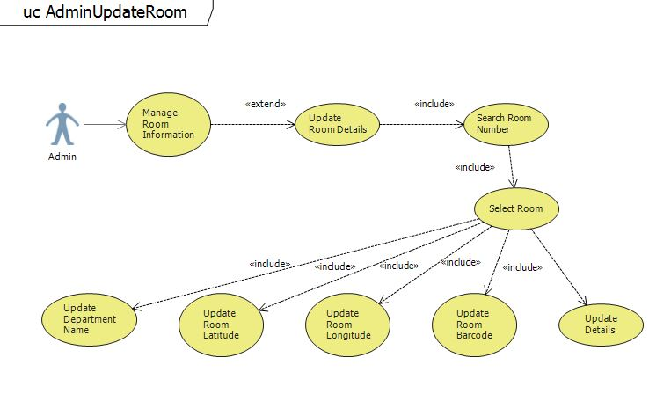

Figure: Use Case Diagram for Updating Room Details Functionality

|  |  |  |  |  |
| --- | --- | --- | --- | --- |
| Update Room Details Use Case | | | | |
| **Use Case Name** | Update Room Details | **Use Case ID** | 3.3.2 |
| **Created By** | Ridhima Joshi | **Date Created** | 09/25/2018 |
| **Updated By** |  | **Date Last Updated** |  |
| **Approved By** |  | **Date Approved** |  |
| **Primary Actor** | Admin | **Secondary Actors** |  |
| **Brief Description** | Admin will be able to add new rooms. | | |
| **Trigger** | Admin selects add new room option. | | |
| **Preconditions** | Admin should be logged in. | | |
| **Postconditions** | New rooms data should be saved in the database. | | |
| **Normal Flows** | 1. Admin logs in the application with valid credentials. 2. Admin selects Manage Room Information option from the menu. 3. Admin selects Update Room Information option. 4. Admin searches the Room Number. 5. Admin selects the room number to be updated. 6. Admin changes the Room Name. 7. Admin changes the Department Name. 8. Admin changes the Room Latitude. 9. Admin changes the Room Longitude. 10. Admin changes the Room’s Barcode Information. 11. Admin clicks on Update button. | | |
| **Alternative Flows** | 1.1 Admin provides invalid credentials.  1.1.1 The username is invalid:  a) The admin is prompted to re enter the username.  1.1.2.The password is invalid:  a) The admin is prompted to re enter the password.  1.1.3. Upon entry of a valid username and password the admin gains entry to the system  11.1 Admin clicks on save button  a)The admin is prompted unable to save the data. | | |
| **Exceptions** |  | | |
| **Priority** |  | | |
| **Frequency of Use** |  | | |
| **Business Rules** |  | | |
| **Other Information** |  | | |
| **Assumptions** |  | | |

**3.3.3 Use Case for Delete Room Functionality**

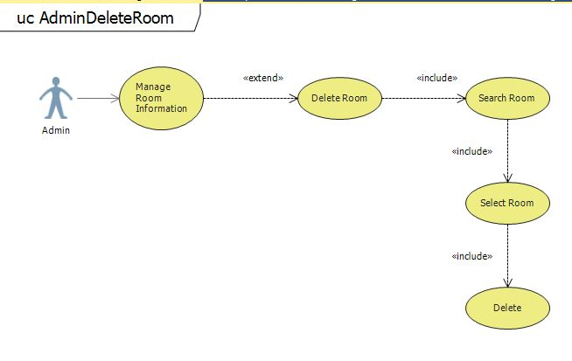

Figure: Use Case Diagram for Deleting Room Functionality

|  |  |  |  |  |
| --- | --- | --- | --- | --- |
| Delete Room Use Case | | | | |
| **Use Case Name** | Update Room Details | **Use Case ID** | 3.3.2 |
| **Created By** | Ridhima Joshi | **Date Created** | 09/25/2018 |
| **Updated By** |  | **Date Last Updated** |  |
| **Approved By** |  | **Date Approved** |  |
| **Primary Actor** | Admin | **Secondary Actors** |  |
| **Brief Description** | Admin will be able to add new rooms. | | |
| **Trigger** | Admin selects add new room option. | | |
| **Preconditions** | Admin should be logged in. | | |
| **Postconditions** | New rooms data should be saved in the database. | | |
| **Normal Flows** | 1. Admin logs in the application with valid credentials. 2. Admin selects Manage Room Information option from the menu. 3. Admin selects Update Room Information option. 4. Admin searches the Room Number. 5. Admin selects the room number to be updated. 6. Admin changes the Room Name. 7. Admin changes the Department Name. 8. Admin changes the Room Latitude. 9. Admin changes the Room Longitude. 10. Admin changes the Room’s Barcode Information. 11. Admin clicks on Update button. | | |
| **Alternative Flows** | 1.1 Admin provides invalid credentials.  1.1.1 The username is invalid:  a) The admin is prompted to re enter the username.  1.1.2.The password is invalid:  a) The admin is prompted to re enter the password.  1.1.3. Upon entry of a valid username and password the admin gains entry to the system  11.1 Admin clicks on save button  a)The admin is prompted unable to save the data. | | |
| **Exceptions** |  | | |
| **Priority** |  | | |
| **Frequency of Use** |  | | |
| **Business Rules** |  | | |
| **Other Information** |  | | |
| **Assumptions** |  | | |

**3.3.4 Use Case for View Room Details Functionality**

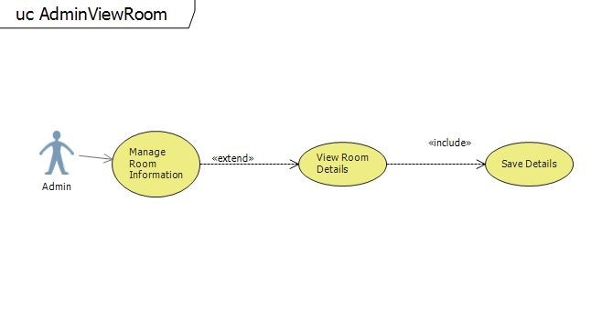

Figure: Use Case Diagram for View Room Details Functionality

|  |  |  |  |  |
| --- | --- | --- | --- | --- |
| View Room Details Use Case | | | | |
| **Use Case Name** | Update Room Details | **Use Case ID** | 3.3.2 |
| **Created By** | Ridhima Joshi | **Date Created** | 09/25/2018 |
| **Updated By** |  | **Date Last Updated** |  |
| **Approved By** |  | **Date Approved** |  |
| **Primary Actor** | Admin | **Secondary Actors** |  |
| **Brief Description** | Admin will be able to add new rooms. | | |
| **Trigger** | Admin selects add new room option. | | |
| **Preconditions** | Admin should be logged in. | | |
| **Postconditions** | New rooms data should be saved in the database. | | |
| **Normal Flows** | 1. Admin logs in the application with valid credentials. 2. Admin selects Manage Room Information option from the menu. 3. Admin selects Update Room Information option. 4. Admin searches the Room Number. 5. Admin selects the room number to be updated. 6. Admin changes the Room Name. 7. Admin changes the Department Name. 8. Admin changes the Room Latitude. 9. Admin changes the Room Longitude. 10. Admin changes the Room’s Barcode Information. 11. Admin clicks on Update button. | | |
| **Alternative Flows** | 1.1 Admin provides invalid credentials.  1.1.1 The username is invalid:  a) The admin is prompted to re enter the username.  1.1.2.The password is invalid:  a) The admin is prompted to re enter the password.  1.1.3. Upon entry of a valid username and password the admin gains entry to the system  11.1 Admin clicks on save button  a)The admin is prompted unable to save the data. | | |
| **Exceptions** |  | | |
| **Priority** |  | | |
| **Frequency of Use** |  | | |
| **Business Rules** |  | | |
| **Other Information** |  | | |
| **Assumptions** |  | | |

**3.4 Use Case for Admin Managing Building Layout Information Functionality**

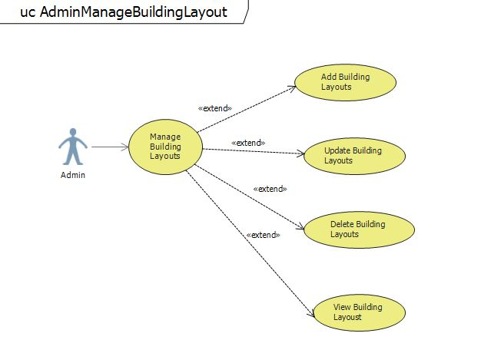

Figure: Use Case Diagram for Admin Managing Building Layout Information Functionality

|  |  |  |  |  |
| --- | --- | --- | --- | --- |
| Managing Building Layout Use Case | | | | |
| **Use Case Name** | Manage Building Layouts | **Use Case ID** | 3.4 |
| **Created By** | Ridhima Joshi | **Date Created** | 09/25/2018 |
| **Updated By** |  | **Date Last Updated** |  |
| **Approved By** |  | **Date Approved** |  |
| **Primary Actor** | Admin | **Secondary Actors** |  |
| **Brief Description** |  | | |
| **Trigger** | The admin will select Manage Building Layout Information option from the menu. | | |
| **Preconditions** | Admin should be logged in. | | |
| **Postconditions** | Admin should view the next menu screen for managing building layout information | | |
| **Normal Flows** | 1. Admin logs in with valid credentials. 2. Admin selects Manage Building Layout option from the menu. | | |
| **Alternative Flows** | 1.1 Admin provides invalid credentials.  1.1.1 The username is invalid:  a) The admin is prompted to re enter the username.  1.1.2 The password is invalid:  a) The admin is prompted to re enter the password.  1.1.3 Upon entry of a valid username and password the admin gains entry to the system. | | |
| **Exceptions** |  | | |
| **Priority** |  | | |
| **Frequency of Use** |  | | |
| **Business Rules** |  | | |
| **Other Information** |  | | |
| **Assumptions** |  | | |

**3.4.1 Use Case for Add New Building Layout Functionality**



Figure: Use Case Diagram for Adding New Building Layout Information Functionality

**3.4.2 Use Case for Updating Building Layout Functionality**



Figure: Use Case Diagram for Updating Building Layout Information Functionality

**3.4.3 Use Case for Deleting Building Layouts Functionality**



Figure: Use Case Diagram for Deleting Building Layout Information Functionality

**3.4.4 Use Case for Viewing Building Layout Functionality**



Figure: Use Case Diagram for Viewing Building Layout Information Functionality

**3.5 Use Case for Admin Managing Colliders Information Functionality**

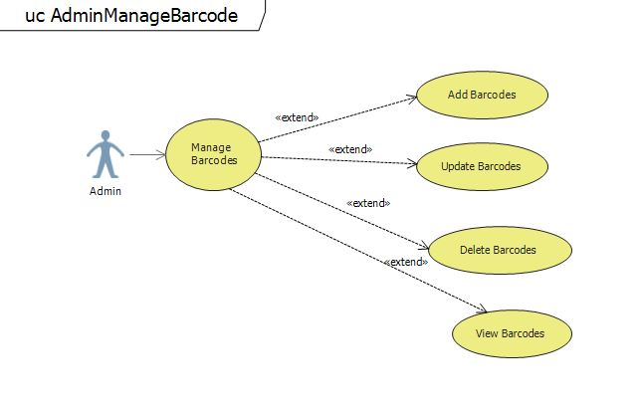

Figure: Use Case Diagram for Admin Managing Collider Information Functionality

|  |  |  |  |  |
| --- | --- | --- | --- | --- |
| Manage Colliders Information Use Case | | | | |
| **Use Case Name** | Manage Colliders | **Use Case ID** | 3.5 |
| **Created By** | Ridhima Joshi | **Date Created** | 09/25/2018 |
| **Updated By** |  | **Date Last Updated** |  |
| **Approved By** |  | **Date Approved** |  |
| **Primary Actor** | Admin | **Secondary Actors** |  |
| **Brief Description** |  | | |
| **Trigger** | The admin will select manage barcode information option from the menu. | | |
| **Preconditions** | Admin should be logged in. | | |
| **Postconditions** | Admin should view the next menu screen for managing users. | | |
| **Normal Flows** | 1. Admin logs in with valid credentials. 2. Admin selects Manage Barcode Information option from the menu. | | |
| **Alternative Flows** | 1.1 Admin provides invalid credentials.  1.1.1 The username is invalid:  a) The admin is prompted to re enter the username.  1.1.2 The password is invalid:  a) The admin is prompted to re enter the password.  1.1.3 Upon entry of a valid username and password the admin gains entry to the system. | | |
| **Exceptions** |  | | |
| **Priority** |  | | |
| **Frequency of Use** |  | | |
| **Business Rules** |  | | |
| **Other Information** |  | | |
| **Assumptions** |  | | |

**3.5.1 Use Case for Add New Collider Functionality**

Figure: Use Case Diagram for Adding New Collider Information Functionality

**3.4.2 Use Case for Updating Collider Functionality**

Figure: Use Case Diagram for Updating Collider Functionality

**3.4.3 Use Case for Deleting Building Layouts Functionality**

Figure: Use Case Diagram for Deleting Collider Functionality

**3.4.4 Use Case for Viewing Collider Information Functionality**

Figure: Use Case Diagram for Viewing Collider Information Functionality

**3.6 Use Case for Admin Logout Functionality**

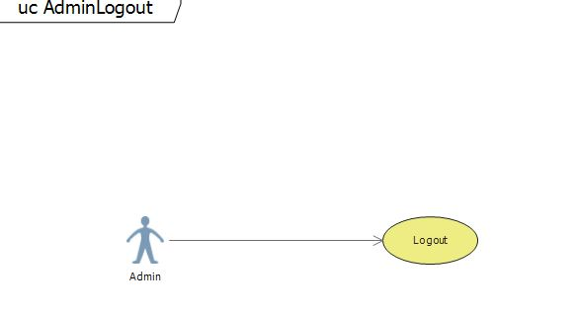

Figure: Use Case Diagram for Admin Logout Functionality

|  |  |  |  |  |
| --- | --- | --- | --- | --- |
| Admin Logout Use Case | | | | |
| **Use Case Name** | Admin Logout | **Use Case ID** | 3.6 |
| **Created By** | Ridhima Joshi | **Date Created** | 09/25/2018 |
| **Updated By** |  | **Date Last Updated** |  |
| **Approved By** |  | **Date Approved** |  |
| **Primary Actor** | Admin | **Secondary Actors** |  |
| **Brief Description** | Admin wants to exit the application. | | |
| **Trigger** | Admin clicks on Logout button. | | |
| **Preconditions** | Admin must be logged in. | | |
| **Postconditions** | Admin must be exit the application. | | |
| **Normal Flows** | 1. Admin clicks on the Logout button. | | |
| **Alternative Flows** | None. | | |
| **Exceptions** | None. | | |
| **Priority** | Medium | | |
| **Frequency of Use** |  | | |
| **Business Rules** |  | | |
| **Other Information** |  | | |
| **Assumptions** |  | | |

Use Case Scenario #4 Timer

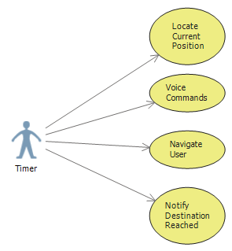

|  |  |  |  |  |
| --- | --- | --- | --- | --- |
| Timer Use Case | | | | |
| **Use Case Name** | Timer | **Use Case ID** | 4 |
| **Created By** | UI Interior | **Date Created** | 09/25/2018 |
| **Updated By** | Saiphanideep | **Date Last Updated** |  |
| **Approved By** |  | **Date Approved** |  |
| **Primary Actor** | Timer | **Secondary Actors** |  |
| **Brief Description** |  | | |
| **Trigger** | Knowing the current position of the user. | | |
| **Preconditions** | Know the current position of the user. | | |
| **Postconditions** | Notify when the destination is reached. | | |
| **Normal Flows** | 1.Knowing the current position of the user.  2.Navigating the user.  3.Sending the voice commands.  4.Notifying the user when the destination is reached. | | |
| **Alternative Flows** | None. | | |
| **Exceptions** |  | | |
| **Priority** |  | | |
| **Frequency of Use** |  | | |
| **Business Rules** |  | | |
| **Other Information** |  | | |
| **Assumptions** |  | | |